**Chapter 1**

**1.1 Introduction**

Although crime on college and university campuses in the Republic of Zimbabwe has existed since their founding and despite available data, unanswered questions remain about the scope and nature of the problem. Notwithstanding these knowledge gaps, beginning in the late 1980s and the 1990s campus crime was covered by the media and various interest groups, whose claims about the problem spurred efforts by policy makers, the courts, and post-secondary administrators to address it. The effects of their efforts, however, have not been well documented, as most have never been evaluated.

Ultimately the picture that emerges from forty years of available research is that college and university campuses are neither immune to the problem of crime and violence.

Nowadays the society consists of increasing degrees of global social immobility and uncertainty pertaining to ranges of threat posed by interior and exterior security threats. Within this climate security driven with the aid of technology is increasingly being used by governments, institutional organizations and individuals to monitor and reduce chances of danger. There has been a belief that the criminal justice system is constrained in its ability to control crime which has led to the exploration of different avenues for tackling crime and this has provided a market for private organizations to push ahead the growth of technological security innovations. Crime is a human experience and is as ancient as the human race. Crime is geographical. It takes place at a particular place, specific time and for a particular reason. It can have an effect on all of us and anyone at any time.

Both Information Technology and crime are complex and constantly changing. Social and technological changes introduce new targets, equipment and factors for crime. E-crime targets encompass private information, technical infrastructure and denial of service. Improved and faster technology and global communications make it less complicated to both organize and conceal crime. Software to assist criminals is available, even as business products: criminals have used attack-testing software program to probe the security of target systems. Motivations now consist of terrorism and revenge as well as traditional needs for economic gain. Terrorists would possibly not be rational in their motivation; casual opportunists look for an open door; organised crime will evaluate viable positive aspects towards funding – which would possibly be massive if the potential rewards are appealing enough.

**1.2 Background**

The University of Zimbabwe security patrols the Mt Pleasant campus 24 hours a day, 365 days a year, using cars, bikes, and other officers on foot.

The University Security has a crew of officers committed to neighbourhood relations and crime prevention that coordinates various security cognizance programs for the campus community, in particular to motivate students and staff to be accountable for their personal safety and the safety of others. Printed and digital materials are positioned on notice boards frequently and at galas to supply crime prevention pointers and information.

**1.3 Problem definition**

At the University of Zimbabwe, we have discovered that the crime level is increasing. Our survey demonstrates that hundreds of crimes go unreported on Campus. The main problems are that students are afraid or do not have enough time to go to the Campus control room to report crimes. The current system is faced with several difficulties as there is no instant means of reporting crimes to the Campus security Department other than calls, messaging or perhaps face to face which is cumbersome especially where the reporter wishes to keep anonymity. For example, students were afraid to report the recent accommodation scandal, because they had to report personally to the accommodation department.

We intend to improve the following problems of the current manual system: more man power, time consuming and not user friendly, bribery, counselling facilities and also try to facilitate the inclusion of higher officials in crime resolution strategies.

**1.4 Hypothesis:**

By using computerized system instead of manual system, we will solve delimitations existing system and make the working more accurate. For example, file searching to know the previous status of the person who committed crime is difficult and cumbersome in manual system, but in case of proposed system it is easy and fast.

By developing web-based application titled Campus Crime Reporting and Management System, we hope it can minimize crime on Campus. Here the administrators will release some important information on the platform as crime alerts so that people can get some awareness pertaining to campus crime.

**1.5 Purpose**

The online system will provide an anonymous and secure mechanism for both victims and witnesses to report crimes to the Campus security department. We have developed the portal of reporting crime, the portal can handle records of persons who are suspects, wanted or are under trial. This portal will be most useful for any University of Zimbabwe stakeholder intending to report, track or view crime statistics. Anyone can report a crime online, missing Laptops, vehicle and things secure registration and profile management facilities, reduce the work of security and students and also reduce the time consumption.

**Inspiration**

The platform was inspired by various motives why people ought to report crime and why people prefer to examine or pay attention to testimonies of crime:

1. Students regularly desire an explanation of why crimes happen at campus. They may also prefer to understand so that they can prevent a similar issue occurring to themselves.
2. Students need to understand how legal guidelines are broken, and how offenders who break laws are caught and punished. This helps them apprehend what legal guidelines are and what the penalties for breaking them are.
3. Students as well as staff have a role to play, in supplying data to counteract rumour. People will hear about crimes via informal conversations or rumour, or they may also hear a siren as a police vehicle dashes along the road; they will be only half-informed. It is our job to inform them the complete truth about the rumoured crime or give an explanation for why the police vehicle went past.
4. Students will go to the internet site or tune our Android app as a way of making certain they understand what is going on.

**1.6 Project Description**

The proposed crime reporting system aims to assist the University of Zimbabwe Security Department in their bid to handle crimes with timely and useful information about criminals and/or their mode of operations so as to reduce criminal activities on Campus. This is a platform where students can actually report campus related crimes of any sort. The system is web-based supported by a mobile application (android) that has most of the major functions of the web. The crime reporting system that will be developed heavily rely on the crime report forms that will be submitted online by Users. The system consists of four User levels with different access levels namely: Admin, Security Official, regular User and Visitor. The system allows users to file case or report crime by giving the details of the crime, time of occurrence, crime description, name of the reporter just to mention a few. Users can also view the most wanted criminals on campus and provide details, if they know any whereabouts of the criminal on the run. Members can also search certain crimes if they want to know the details of the crime. The members can view the crimes they have reported if there are any. All these activities can take place after the member has logged in to the system. Member are obliged to give evidence if there is any and give any suspects that is if there are any also.

The security departments will get notifications every time a new crime is reported and they start their investigations of the crime.

**1.7 Research Objectives**

* To minimize crime on Campus
* To facilitate prompt crime reporting on Campus
* To develop a software platform for reporting crime
* To develop a software for managing criminal records
* To minimize time and materials consumption through the automation of already existing systems.
* To allow students to report anonymously by reporting before logging in if the reporter is not interested in being known
* To reduce the workload of having to do the task manually which is somehow exhausting
* To allow students to report their crimes in the comfort of their hostels in case the crime happened at night.

**1.8 proposed benefits of the system**

* Simplified process for reporting and tracking crimes
* Faster and assured response from Security for any emergency calls for assistance
* Enhanced ability to analyse crime patterns
* Improved relationship management for reporters, victims and witnesses
* Better coordination and communication between members and the security department through implementation of information exchange system.

**1.9 Organizing of the project/ Presentation of work**

The project will move as described below:

* **Chapter 2**

Covers the system specification for Campus Crime Reporting Management system, that is, the functional and non-functional requirements. Also the system scope, feasibility study and user interface design are fully described in this chapter

* **Chapter 3**

Covers Project planning outlining the planning process and scheduling of the system development process. All the system processes and models are described in this chapter.

* **Chapter 4**

Is the System Analysis and design. This chapter helps in clarifying the purpose and functionality of the Campus Crime Reporting and Management System and helps in significantly reducing the cost and effort of future maintenance and enhancement of the system. It also provides the system architecture, system entities and relationships, equipment configuration, database design, physical design and module design specification.

* **Chapter 5**

It is the implementation and Testing Phase. It covers choosing the language and the choice of environment, verification and validation of the system project and the test results

* **Chapter 6**

Encompasses the conclusion of the whole Campus Crime reporting and management system project sections. A summary of the project, Problems Encountered and, suggestion for better Approaches to problem/Project, and suggestions for future extension of the project

**Chapter 2**

**2. System specification**

**2.1 Introduction**

This chapter aims to elaborate functional and non-functional requirements of the system to be developed and implemented. The tools, third part application, as well as users’ levels of access (views) and privileges used will also be noted in this chapter. It serves as description of how the system to be developed is intended to work, hence it provides the detailed system description. Again, in this chapter, a feasibility study will be conducted, to test whether or not the system is worthwhile.

* 1. **System functional specifications**
     1. **Functional Requirement**

The requirements specified under this heading are more concerned with what the system is supposed to do.

**General Objectives.**

* To establish a system with an effective security system where unauthorized access by any unauthorized user will be tightly controlled and monitored.
* To establish a web site and an android application accessible anywhere by any user as long as it is connected to the internet and an android app which can be accessible even without internet connection, using Local Area Network (LAN).
* To store our system in a google drive and local storages like external hard drives and Discs, which will be an effective and efficient backup recovery system whenever the system is affected or data is lost.
* To establish a system in which when processing information there will be limited to no errors.

**2.2.2 Specific Requirements**

General Modules Specification

Registration Module:

* New user can register in the system to become members.
* The users will register using their registration numbers for students and employment numbers for security. This is to avoid the risk of letting users choose their user type because some users may select the security type in order to have more privileges.

Login Module:

* Using the username and password admin and all Member can login into the system and manage the application.
* The login details will be matched against the details stored in the database in order to determine the user type.
* Users can be either students, staff, security officers or administrators.

Member Module:

* Each of member view the criminal records and status.

Report Crime Module:

The system shall allow student and other users to file their cases or report any particular crime. Users will provide specific details of the crime such as:

perpetrator’s name

victim’s name

victim’s contact details, if any

description of the crime

time of occurrence

upload evidence (video, picture or audio)

an optional field for name of the person who filed the case.

Date of occurrence

Crime related causes

Wanted persons Module

* It will have two categories, wanted persons and most wanted persons.
* Most wanted criminals are notorious perpetrators who are not yet convicted, they will be indicated by red colours. The system shall retrieve both wanted and most wanted criminals list form the database.
* The list will be displayed in tabular format. Users can click on a particular record in order to view more details such as description and evidence The details for wanted persons will include:

✓ The picture of the wanted person

✓ Name of the person wanted

✓ Gender

✓ Recent where about of the person

✓ Reason why he is on the most wanted section

Cases Module

* This module will retrieve all reported crimes that have been approved.
* The system will display brief details for each crime entry. It will also provide a “more details” button. The option will display full records relating to a particular criminal if clicked. This will only be applicable on the website platform.

My Cases Module

* The system shall display all cases that the current logged in user would have reported.
* The user can remove any cases from the list.
* The user can add more details about the crime but will not be allowed to remove any information.

.

Search Module.

* The system shall enable user to enter the search text on the screen. Search text can be either crime number, criminal’s name, type of crime or any other relevant text.
* This module shall display, at most twenty matching results on the current screen and prompt the user to click to see more results.
* It will enable user to navigate between the search results which are also clickable to see more details.
* The user will be notified when no matching product is found on the search. A search filter will also be included to allow user to get more specific results by entering dates, crime type, victim’s name etc.

Victim Support Module:

* Victims seeking assistance can communicate with the security personnel using this special platform.
* Victims can ask the security if they have recovered lost property yet.
* Protection against physical threats and bullies can be reported here to get special assistance.

Users’ profile Module.

* The system shall allow user to create profile and set his credential and login to the system. The system shall allow user to update the profile information.
* Users will be able to update their personal information such as email, password and program using this information.

Help and Support Module

* The system shall provide help to users on how to use the system.
* Questions that benefits several people can be directed to the Security through this channel.
* Only questions that are serious, not controversial and non-personal questions will be replied and posted on the platform for consumption of all.

**Security Module Specification**

1. Print Report Module

The system shall print a detailed report of a single crime record or several crime records.

1. Approve Reports Module.

The security will notify the security personnel if a crime is reported.

The report will have to be evaluated before posting it on the public domain.

Details of the crime can be updated after the report but the original reported details are still kept in the database.

1. Update Cases Status

The reported cases will be assigned a default status of “pending review” just after being reported.

Cases will have to be updated to either: under investigation, convicted, wanted, pending trial etc.

1. Investigation Team

The security admin will set up an investigation team and allocate officers once a report is filed.

The number of allocated officers will be allocated according to ranks and the nature of report.

**Admin Modules**

1. Update Cases Module

This module will be only visible to administers.

It allows Administrators to alter crime records, updating and changing crime, criminal and other crime related information.

Admin can change the status of a case through this channel.

1. Create User Module

Security and Administrator users can only be created by the Admin.

This special type of users cannot register themselves through the registration module.

1. Manage Users Module

The administrator can change the system’s users.

Users can be added or deleted from the system.

**2.2.3 Non- Functional Requirements**

Non-functional requirements describe how a system must behave and establish constraints of its functionality. This type of requirements is also known as the system’s performance requirements or quality attributes. These are the constraints or the required performance or behaviour of the system during it use:

**Server-Side Requirements**

|  |  |
| --- | --- |
| Processor | Intel® processor with support for Intel® VT-x, Intel® EM64T (Intel® 64), and Execute Disable (XD) Bit functionality. |
| RAM | 2GB |
| Hard Disk | 20GB free space |
| Languages | PHP, MySQL |

*Table 2.1 - Server-Side Requirements*

**Client-Side Requirement:**

**Web Based**

|  |  |
| --- | --- |
| Software |  |
| Front-End | HTML, CSS, BOOTSTRAP |
| Back end | MySQL server 2008 |
| Web server | XAMPP |
| Operating System | Windows 7 up to latest |
| Browser | Internet Explorer 6.0 or any other compatible browser |
| Hardware |  |
| Processor | Dual core or later |
| Hard disk space | 4GB free space |

*Table 2.2 web-based requirements*

**Android**

|  |  |
| --- | --- |
| **HARDWARE** |  |
| RAM | 4GB |
| Hard Disk | 8GB |
| Operating System | Windows 8.1 and later |
| Processor Speed | Clarion Dual Core and above |
|  |  |
| **SOFTWARE** |  |
| Devices | Any android mobile from ice cream version to latest |
| Material | Android Studio |
|  |  |

*Table 2.3 Android requirements*

**2.2.4 System Performance Requirements**

System Efficiency

The system should facilitate quick crime response. The system will be very efficient, since its operations will be made in real time, with the use of strong network systems, making it able to produce data needed in an almost real time case. For example, for example accessing the website and reporting a crime is possible within a minute.

Reliability

The system has been designed to be both web-based and android system, which works with the use of internet power, hence as long as network systems are well configured, it works accurately with limited chances of failure. It is expected to produce the correct information since the crime reports will be validated and approved by security personnel before being posted to the platform. Hence it is a reliable and accurate software system.

Usability

The system to be developed will use simple English. It has controls that give understandable error messages and also provide suggestions for the user. This enables the user to fully understand the system, interact with it and be able to produce the desired results from it. It also allows the user to easily navigate over the system interface, by way of navigations and suggested guidelines without any challenges.

Security

The system shall ensure that information provided by users is protected from unauthorized access to the system and its stored data. There will be **different levels of authorization and authentication across different user’s roles**. Thus, different users such as Admin, Security Personnel, authenticated users and visitors will have different **views and privileges**. For example, only Administrators and security personnel will be allowed to create, see, copy, change, or delete information for some records to avoid information misuse by third parties. The system will also be protected against viruses and malware attacks. Security can be divided into the following sub categories:

Maintainability

The system to be developed has to provide room for modification from the purpose of meeting changes in user requirements or meeting new need, hence need to use object-oriented principle for easy maintainability. Again, the system should offer backup facility such as data recovery easily in cases of unplanned system failures.

Modifiability

The system is capable of being modified to meet changes in the user requirements above-mentioned.

Portability

The system shall be portable to the extent that it can be used on different operating system and the application on different android devices.

The website will be full available on both desktops and mobile phones.

The Android application is also portable supporting many versions.

**2.3 System Evolution**

In the near future, improvements may bring in new alarming methods, for example the Omni Systems used by the FBI. More developments, such as support for IOS systems which work more efficiently than the Android ones used in this system. Android was used instead of IOS because most of the targeted users are still on Android. Apple phones are still limited to the elite. We hope to add the use of google maps to send the co-ordinates of the actual crime scene immediately and add a web camera feature that can allow reporters to capture evidence live plus many other features.

**User specification:**

**Admin:**

Admin will be Protected by username and password. Other users of website will not be permitted to access information reserved for the Admin User. Admin can manage all record related to application that manage the crime detail. Crime records can only be edited or deleted by an Admin. Admin can also manage other system users.

**Security personnel:**

Reported Crimes are Approved by the Se]curity personnel before being published to avoid malicious prosecution and deformation of Character charges. Security officers will have to investigate the authenticity of the report first before it is broadcasted on the website. Security can manage crime details and question. The Security will set up an investigation team to infer with reported matters.

**Authenticated User:**

This includes students and staff who would have registered. Authenticated users will be able to report crime, track crime details, view cases and see criminal profiles.

**Unauthenticated User (Visitor):**

Visitors includes not yet registered users Visitor can report crime, view news, Post question, add inquiry and give answer of question and feedback.

Reporting crime doesn’t require authentication in order to reduce time wastage, ambiguity and also allow room for anonymous reporting.

**2.4 Feasibility Study**

Feasibility study is the assessment of the extent to which the system will meet the objectives of the users, possibility of interaction with other systems and whether or not the system can be recognized with current technology.

**2.4.1 Economic Feasibility**

This is a cost benefit analysis or an attempt to find out whether the benefits justify the cost of developing the system. From the developer’s point of view, this project got the benefits outweighing the cost as below.

Tangible Cost Benefit.

Development cost and operational benefits quantified in dollar terms.

Operational Benefits

Cost reduced by reducing the paperwork used. For examples instead for visiting the security department to get help or report the case, the system can be used instead. There is free acquisition of information through the system of wanted people etc. The system allows user to post evidence efficiently via the system which reduces the risk of losing it before handing it over to the security manually.

Development Costs

Here we are looking at the costs of purchasing the hardware and software required in building the system.

**Software**: the main software’s to be used that is XAMP and Android Studio are obtainable from the university of Zimbabwe Computer science department or downloaded from the internet also freely since they are **open source software’s**. Hence there is no software cost. **Hardware:** two of the developers’ personal computers all operating windows 8 or later can be used for the development. Also, the University of Zimbabwe Software Lab will be used for developing the project and access the internet. However, the problem with the lab is that times may clash when developers need to use the lab lecturers delivering their lectures. Therefore, it’s best to use the developer’s personal computer which is costly to purchase them.

**Intangible cost benefits**

Benefits difficult to quantify in dollar terms but enjoyed by the user through using the system.

Convenience: the system should be accessible anywhere, anytime as long as one is connected to the internet.

**2.4.2 Technical feasibility**

It takes into consideration whether or not the developers can develop the system with the existing level of knowledge.

**Technical Experience**

The developers have studied the database design especially MYSQL which will be used in this project. They also possess more basic knowledge on how to use a computer and they are well experienced as far as using Windows 8 and above operating systems. In addition, the developer has good understanding of python and java programming which they will be needed in the development of android app. The developers also have knowledge of **HTML, CSS, Bootstrap and PHP** which are needed in this project. However, since we are still learning there is need for us to get assistance from the internet if needed.

**Availability of necessary equipment**

The University of Zimbabwe Computer Science lab has computers which can be accessed by the developers and provide the internet facilities as well. Also, the developers have their own personal computers which may also come handy outside the University normal working hours.

**2.4.3 Operational Feasibility**

Will the system be usable to the intended environment after completion?

From the developers’ point of view, the answer is yes. We hope that the users will be grateful for our system since it has so many fore mentioned benefits.

**2.5 Conclusion.**

In one whole, the requirements of the Campus Crime Reporting and Management System are as verbalized in this chapter. The developers also considered the system feasible enough to proceed as indicated by the feasibility study. The given prototype is a guide on how the system will be used.

**Chapter 3** Process Planning

**3.0 Introduction**

This chapter seeks to outline the planning process, scheduling of the system development process.

**3.1 Project planning and scheduling**

This section serves to establish the way forward or the phases the project goes through and any stops checks if any. The following table depicts the phases in which the project will be developed with the time left.

**Work Plan.**

|  |  |  |  |
| --- | --- | --- | --- |
| Task | Start | Finish | Duration |
| Problem Definition | 24 August 2019 | 30 August 2019 | 1 week |
| Planning | 06 September 2019 | 12 September 2019 | 1 week |
| Analysis phase | 12 September 2019 | 18 September 2019 | 1 week |
| System design | 18 September 2019 | 2 October 2019 | 3 weeks |
| Implementation | 2 October 2019 | 08 November 2019 | 3 weeks |
| Maintenance | 09 November 2019 | 18 November 2019 | 1 week |

*table 3.1 – Work plan*

**Gantt Chart**

|  |  |  |  |  |  |  |  |  |  |
| --- | --- | --- | --- | --- | --- | --- | --- | --- | --- |
| **Week/ Stage** | **1** | **2** | **3** | **4** | **5** | **6** | **7** | **8** | **9** |
| Documentation |  |  |  |  |  |  |  |  |  |
| Project Proposal |  |  |  |  |  |  |  |  |  |
| Planning Phase |  |  |  |  |  |  |  |  |  |
| Analysis Design |  |  |  |  |  |  |  |  |  |
| Design |  |  |  |  |  |  |  |  |  |
| Implementation |  |  |  |  |  |  |  |  |  |
| Maintenance |  |  |  |  |  |  |  |  |  |

*Chart 3.1 – Gant Chart, working stages*

**3.2 Process Model**

One of the basic notions of the software development process is SDLC models which stands for Software Development Life Cycle models. SDLC – is a continuous process, which starts from the moment, when it’s made a decision to launch the project, and it ends at the moment of its full remove from the exploitation. There is no one single SDLC model. They are divided into main groups, each with its features and weaknesses.

Evolving from the first and oldest “waterfall” SDLC model, their variety significantly expanded. The SDLC model’s diversity is predetermined by the wide number of product types – starting with a web application model to a complex medical software. And if you take one of the SDLC models mentioned below as the basis – in any case, it should be adjusted to the features of the product, project, and company. The most used, popular and important SDLC models are given below:

* Waterfall model
* Iterative model
* Spiral Model
* V-shaped model
* Agile Model

No matter what type of the models has been chosen, each of them has basic stages which are used by every software development company. However, in order to develop our project, we are going to use waterfall model.

**3.2.1 Waterfall Model**

The Waterfall Model was the first Process Model to be introduced. It is very simple to understand and use. In a Waterfall model, each phase must be completed before the next phase can begin and there is no overlapping in the phases. Waterfall model is the earliest SDLC approach that was used for software development.

In “The Waterfall” approach, the whole process of software development is divided into separate phases. The outcome of one phase acts as the input for the next phase sequentially. This means that any phase in the development process begins only if the previous phase is complete. The waterfall model is a sequential design process in which progress is seen as flowing steadily downwards (like a waterfall) through the phases of Conception, Initiation, Analysis, Design, Construction, Testing, Production/Implementation and Maintenance.

As the Waterfall Model illustrates the software development process in a linear sequential flow; hence it is also referred to as a Linear-Sequential Life Cycle Model.

Requirements

System Design

Implementation

Integration and testing

Deployment

Maintenance

*Illustration 3.1 – waterfall model*

**Stages in the waterfall Model**

**Requirements:**

The first phase involves understanding what needs to design and what is its function, purpose, etc. Here, the specifications of the input and output or the final product are studied and marked.

**System Design:**

The requirement specifications from the first phase are studied in this phase and system design is prepared. System Design helps in specifying hardware and system requirements and also helps in defining overall system architecture. The software code to be written in the next stage is created now.

**Implementation:**

With inputs from system design, the system is first developed in small programs called units, which are integrated into the next phase. Each unit is developed and tested for its functionality which is referred to as Unit Testing.

**Integration and Testing:**

All the units developed in the implementation phase are integrated into a system after testing of each unit. The software designed, needs to go through constant software testing to find out if there are any flaw or errors. Testing is done so that the client does not face any problem during the installation of the software.

**Deployment of System:**

Once the functional and non-functional testing is done, the product is deployed in the customer environment or released into the market.

**Maintenance:**

This step occurs after installation, and involves making modifications to the system or an individual component to alter attributes or improve performance. These modifications arise either due to change requests initiated by the customer, or defects uncovered during live use of the system. The client is provided with regular maintenance and support for the developed software.

All these phases are cascaded to each other in which progress is seen as flowing steadily downwards (like a waterfall) through the phases. The next phase is started only after the defined set of goals are achieved for the previous phase and it is signed off, so the name “Waterfall Model “

Reasons using Waterfall Model

* It clearly laid out activities that succeed each other and brought out the emphasis that Specification, development and validation were interleaved
* Aided with prototype, it will better deliver a system that will meet user specification functionality and non-functionality
* Easy to manage due to the rigidity of the model, each phase has specific deliverables and a review process
* Works well for smaller projects.

Advantages of the Waterfall Model

* The advantage of waterfall development is that it allows for departmentalization and control. A schedule can be set with deadlines for each stage of development and a product can proceed through the development process model phases one by one.
* The waterfall model progresses through easily understandable and explainable phases and thus it is easy to use.
* It is easy to manage due to the rigidity of the model – each phase has specific deliverables and a review process.
* In this model, phases are processed and completed one at a time and they do not overlap. Waterfall model works well for smaller projects where requirements are very well understood.

Disadvantages of Waterfall Model

* It is difficult to estimate time and cost for each phase of the development process.
* Once an application is in the testing stage, it is very difficult to go back and change something that was not well-thought out in the concept stage.
* Not a good model for complex and object-oriented projects.
* Not suitable for the projects where requirements are at a moderate to high risk of changing.

**3.3 Conclusion**

The planning process and scheduling systems development process in this chapter enables the developers to come up with an efficient system on time.

**Chapter 4**

System Design

**4.0 Introduction**

System design is the process of designing the elements of a system such as the architecture, modules and components, the different interfaces of those components and the data that goes through that system.

The purpose of the System Design process is to provide sufficient detailed data and information about the system and its system elements to enable the implementation consistent with architectural entities as defined in models and views of the system architecture. The most creative and challenging phase of the system life cycle is system design. The term design describes a final system and the process by which it is developed. It refers to the technical specifications that will be applied in implementing the proposed system. It also includes the construction of program and designing of output, input, code, database and process of the system. The developers will employ tools such as entity relationship diagrams, dataflow diagram, architecture design and also database queries for easier understanding of the system.

**4.1 System Architecture**

The logical system design reviews the present system and prepares input and output specifications, editing, security and control specification details of the implementation plans.it defines the structure and organisation of components and subsystem interacting with the complete system.it tries to show the interrelationship that exists among independent units and how such sub system result in the whole system when combined.

database

Security

Reporter

complaint reports

*Illustration 4.1 System architectural design*

**4.1.1 Use case Diagram**

In designing an efficient and effective system it is important to consider use case diagram. Use case diagram is one of the five diagrams in YML or modelling the dynamic aspects of the system. Use case diagram is central to modelling the behaviour of a system, a subsystem or a class. Use case diagram are more important for visualizing, specifying and make systems, subsystems and classes approachable and view of how those elements may be used in context.

**Use cases are crucial in identifying:**

• How end users perform tasks

• Exact tasks, objects manipulated, and workflow (these can then be elaborated further)

• System features

**Use case for Campus Crime reporting and Management System**

**Security**

**Official**

**Admin**

**Member**

**Visitor**

*Illustration 4.2 – Use Case diagram*

**Visitor**

An unauthenticated user or member can file a new crime report (FIR). He will enter all details about the crime. It contains the crime description, victim’s name, offender’s name, date, time, spot, nature of crime, location of crime and upload evidence files that can be ether videos, audios or images. Members can view all crimes approved by the administrator or the security. Thus, he can see whether the crime reported by him has been accepted or not.

**Administrator**

The Administrator will approve genuine complaints or reports supported by sufficient evidence or witnesses willing to testify. Administrator view complaints from the users, crime details, criminal details, and victim details, witness details. He can create a new investigation team and assign them to the investigation of a crime. Removal of old and outdated crime details and users will only be done by the Administrator. Editing records will also be a responsibility of the Administrator.

**Security**

The Security team at the Control Room can also view the complaints reported by the users. Then they will prepare the FIR and send the FIR to the administrator. The Administrator will assign a team for the investigation. After investigation all details are entered into the software and the Administrator will close the Crime File. This security team can search the crime by nature of crime, victim, complaint, date and time wise.

**4.1.2 Dataflow Diagrams**

Online Crime Reporting and Management System Data flow diagram is used as a preliminary step to create an overview of the Crime Reporting without going into great detail, which can later be elaborated. It consists of overall application dataflow and processes of the Crime Reporting process. It contains all of the user flow and their entities such all the flow of Cases, Criminal, Wanted persons, Users, Reporters. All of the below diagrams have been used for the visualization of data processing and structured design of the Crime Reporting and Management System process and working flow. Dataflow diagram is used to define the flow of the system and their resources. It is the way of expressing system requirements in a diagrammatical way.

**System Dataflow diagrams**

**Level Zero DFD**

The Level Zero DFD of Online Crime Reporting and Management System showcase the high-level process of Crime Reporting. It’s a basic overview of the whole Online Crime Reporting and Management System or process being analysed or modelled. It’s designed to be an at-a-glance view of Reporters, Security and Visitor showing the system as a single high-level process, with its relationship to external entities of Crime, Criminal and Case. It should be easily understood by a wide audience, including Crime, Case and Security In level zero DFD of Online Crime Reporting and Management System, we have described the high-level flow of the Crime Reporting system.

**Level zero Data Flow Diagram for campus crime reporting and management system**

Criminal Management

Crime Management

System user management

Login Management

*Illustration 4.3 – Use Case diagram*

**First Level Data Flow Diagram**

First Level DFD (1st Level) of Online Crime Reporting and Management System shows how the system is divided into sub systems (processes), each of which deals with one or more of the data flows to or from an external agent, and which together provide all of the functionality of the Online Crime Reporting and Management System as a whole. It also identifies internal data stores of Reports, Crime, Security and Case that must be present in order for the system to operate, and shows the flow of data between the various parts of Crime, Case, Reports, Security of the system. DFD Level 1 provides a more detailed breakout of pieces of the 1st level DFD. It reveals the main functionalities of Crime Reporting System.

**Level one Data Flow Diagram for campus crime reporting and management system**

Generate wanted person report

Wanted persons Details

Generate system user details

Check user login Details details

Generate criminal report

Generate Crime Report

Generate Case Report

Criminal Management

System user management

Login Management

Case Management

Crime Management

*Illustration 4.2 – Use Case diagram*

**Level two Data Flow Diagram for campus crime reporting and management system.**

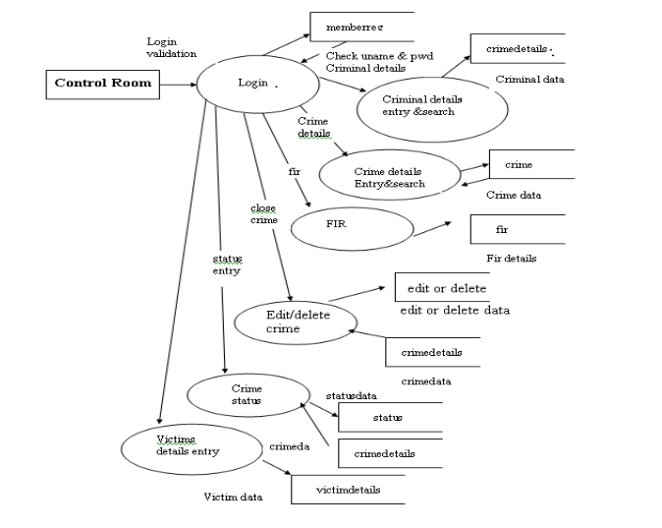

*Illustration 4.4 – Level two Dataflow diagram*

**Second Level Data Flow Diagram**

**Reporter side**

Second Level DFD goes one step deeper into parts of Level 1 of Crime Reporting. It requires more functionalities of Crime Reporting to grasp the necessary level of detail about the Crime Reporting functioning. First Level DFD of Online Crime Reporting and Management System shows how the system is divided into sub-processes. It contains more details of Crime, Reports, Security, Case, Criminal, and wanted Persons.

The reporter can report complaints using this platform. He should provide the complaint details. He can also view the status of his complaint in terms of approval. In case of delayed approval or no approval, the reporter can follow up their case using a reference code that is assigned to each report automatically.

The Administrator has to login to the website. The username and password are checked against those already stored in the database. If they match with the given username and password, he can access the software. The administrator will create a new investigation team and will decide which all members should be in that team. He can view all the reported complaints, and close the complaint file after the completion of the investigation.

**Control Room Side**

The Control Room has to login to the website using the username and password. The username and password are checked. If it is correct, the system will be directed to the Control Room home page. The team can enter the crime details and also approve genuine reports. It can also perform searches. Similarly, he can enter criminal details also. The Control Room can send the FIR to the administrator. He can also set the status, whether the investigation is progressing or if it is closed. He will also enter the victim’s details.

**System Data Stricture Specification**

|  |  |  |  |  |
| --- | --- | --- | --- | --- |
| **Identification** | **Source** | **Input Device** | **Data format** | **Legal-value specification** |
| **User-login Input** |  |  |  |  |
| Email | System user | Keyboard | Any correct email format | All values |
| Password | System user | Keyboard |  | All values |
|  |  |  |  |  |
| **Member registration Details** |  |  |  |  |
| Name | System user | Keyboard | Any characters  Any correct email format | All values |
| Surname | System user | Keyboard | Any characters | All values |
| Password | System user | Keyboard | Any characters(minimum 8 characters) | All values |
| Phone number | System user | Keyboard | Any integers(10 digits) | All valid Zimbabwean number |
| Email | System user | Keyboard | Correct email format | All values |
| Registration Number | System user | Keyboard | In form R------ | All values |
|  |  |  |  |  |
| **Security Registration** |  |  |  |  |
| Name | Security Department | Keyboard | Any Characters | All values |
| Surname | Security Department | Keyboard | Any characters | All values |
| Password | Security Department | Keyboard | Characters and digits | All values |
| Phone Number | Security Department | Keyboard | Any integer (10) | All values |
| Email | Security Department | Keyboard | Any correct email format | All values |
| Security Number | Security Department | Keyboard |  | All values |

*Table 4.1 – data structure specification*

**4.2 System User Interface**

The following images were captured on the user interface designed for this system. Since this system involves user interaction, such a window is required.

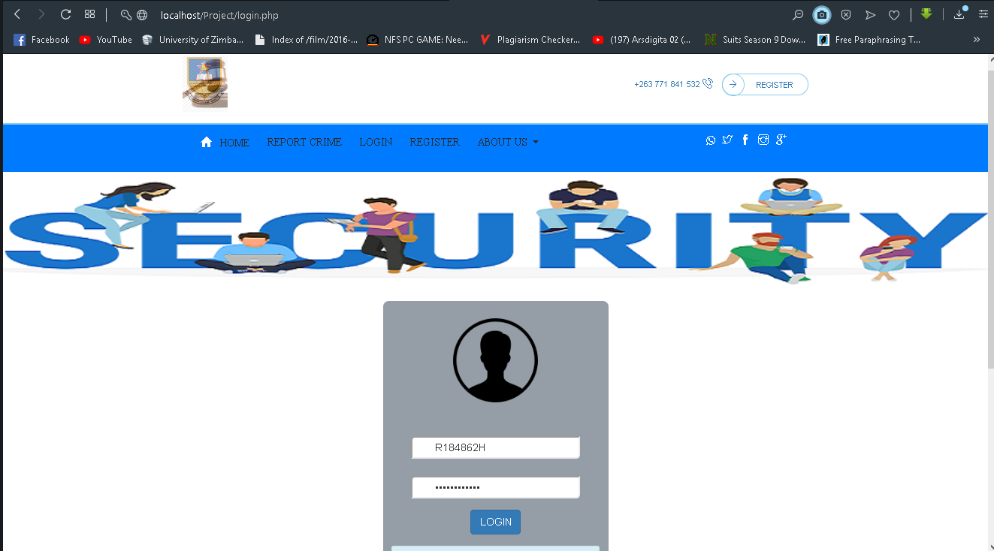

**Reporters can report before logging in to promote anonymity**

Screen shot 4.1 – System user interface design

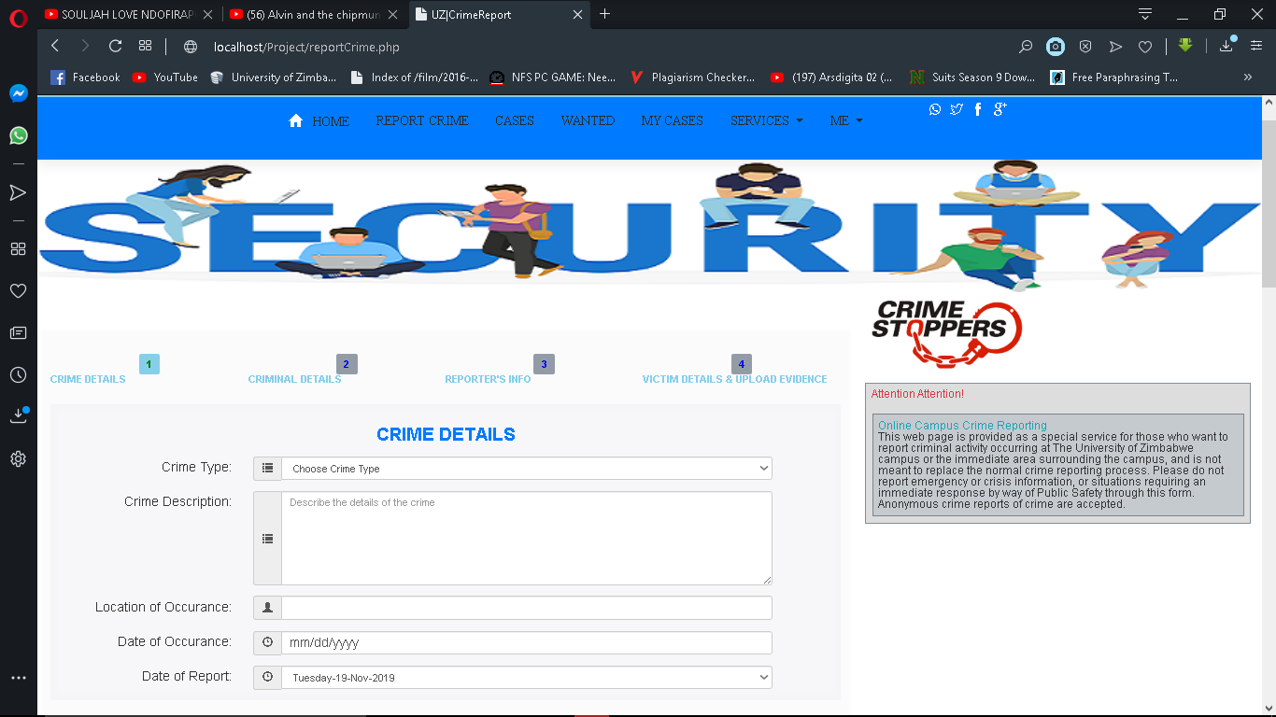

***Screenshot 4.2 –*** *user-friendly input form to report crime*

Crucial information and Attention notices from security department

Reporters will report in crime in stages 1st crime details, 2nd criminal details, reporter info then evidence section

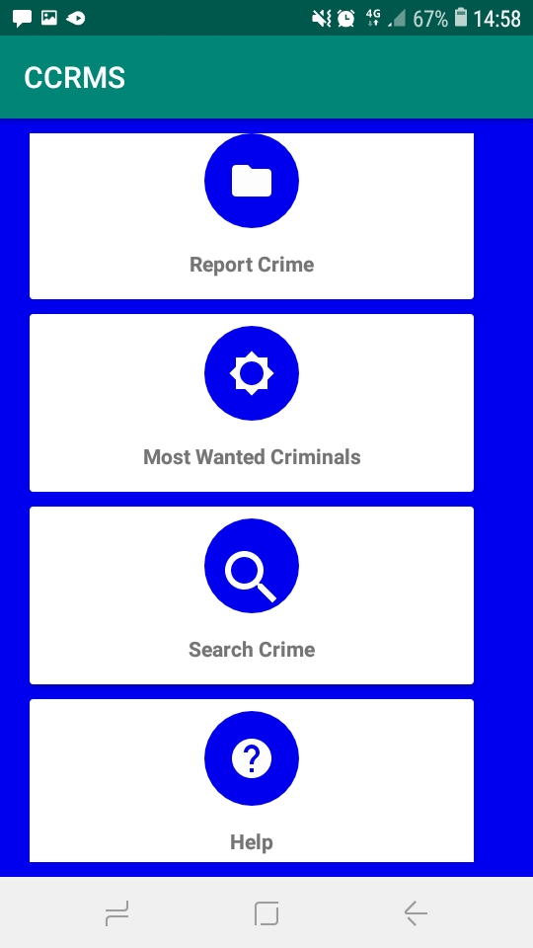**ANDROID APK VIEW**

A short list of on the run criminals can be retrieved from the Application

Users are also able to search crime details

Users can report crime by clicking the report button which invoke the report form to report any crime

**Chapter 5**

Implementation and Testing

**5.1 Introduction.**

The main objective and purpose of the implementation and testing stage is to transform the requirements specification into executable system that the users interact with. This chapter describes and outlines realization process in implementing the Campus Crime Reporting and Management System. The main activities in the development includes the definition of hardware and software requirements, defining database and populating it with test data and finally coding and testing successively and iteratively to develop system prototypes. The final Step is designing the suitable end use system interface provided the functionality is achieved and components are well integrated.

**5.1.1 Choosing the Language**

Programming Language Used:

1. **PHP**

There are several reasons owing to the decision of choosing PHP as an implementation Language. Mainly the selection of PHP to be used as a back-end programming language

was because the developers need not have to worry about the operating system the user is working on. As the PHP code run properly and smoothly on all operating systems. Furthermore, the server-side scripting language or PHP hosting service providers can easily be found. PHP was also chosen as implementation language mainly because of the following reasons.

* It is a high-level language which is closely related to human language, English, and this consequently made the translation from the user’s algorithm design to the systems implementation a relatively simpler task.
* PHP is completely free. It is very budget friendly which makes it more popular. As it is open source, programmers can get it to the internet for free from websites like PHP friends which makes it more economical.
* PHP has a great deal facility that allows easy and direct access to many database engines and this increased the developer’s choice on database selection.
* PHP is easy to learn as compared to many other scripting Languages. It has a syntax that is easy to parse and is actually rather human friendly. The functions, classes and variables are easy to manipulate and use.
* When using PHP, errors can be detected easily because of strong PHP’s debugging engine. Moreover, you can download commercial debugger’s for detecting syntax errors in the code.
* The simplicity of the PHP language is that it is easy to implement as well as to understand popular languages like python which makes it very accessible for all people.
* PHP is a portable programming language which can be run on many operating systems. Therefore, the system can be run on multiple operating systems and still performs the same functions.
* In terms of speed, The PHP engine parses scripts quickly, and has a very collaborative error system, detailing why an error occurred, where it started or ended, and what caused it if applicable.
* PHP can support many databases such as MySQL, oracle, FileZilla etc.
* It is known to be lightweight application as it runs faster on internet and to integrate latest features like AJAX, call back, among others in the applications can be done.
* PHP can be easily embedded into PHP

**Other languages used**

1. **Html**

The developers choose this because of its ability to enhance the designing of interfaces, creation of forms and framesets among other languages.

1. **Bootstrap**

Bootstrap is a web framework that focuses on simplifying the development of informative web pages (as opposed to web apps). The primary purpose of adding it to a web project is to apply Bootstrap's choices of colour, size, font and layout to that project. As such, the primary factor is whether the developers in charge find those choices to their liking. Once added to a project, Bootstrap provides basic style definitions for all HTML elements. The result is a uniform appearance for prose, tables and form elements across web browsers. In addition, developers can take advantage of CSS classes defined in Bootstrap to further customize the appearance of their contents. For example, Bootstrap has provisioned for light- and dark-coloured tables, page headings, more prominent pull quotes, and text with a highlight.

Bootstrap also comes with several JavaScript components in the form of jQuery plugins. They provide additional user interface elements such as dialog boxes, tooltips, and carousels. Each Bootstrap component consists of an HTML structure, CSS declarations, and in some cases accompanying JavaScript code. They also extend the functionality of some existing interface elements, including for example an auto-complete function for input fields.

1. **CSS (Cascading Style Sheets)**

We chose CSS because of its ability to control the style and layout of multiple Web pages all at once.

CSS is a web design tool used to control the layout of a webpage while HTML deals with the actual content. There are different versions of CSS including the kind that is found in the actual HTML code itself, but that defeats the purpose of using CSS in the first place. For better performance and easier maintenance, separate CSS files preferred over embedded CSS. If font, text size, or changes in the appearance of any element are to be made later, simply accessing a separate CSS file is much easier than having to go through extensive lines of code in an HTML file.

1. **JavaScript**

The reason why we chose JS is because of its ability to generate pop-up alert windows and to add functionality, detect browsers etc.

**5.2 Choice of Environment**

for the purposes of this project, the developers chose MySQL database for the following reasons:

* **Fast development** – People are continuously developing new modules for integration with MySQL. This means that it has a wider and faster development circle. Patches, upgrades and fixes are developed fast and become available in forums, blogs and developer sites on the internet.
* **Operability Across Platforms**- MySQL is easily installable and operable on different platforms including Windows, Linux. MySQL database system also contains APIs for integration with other languages like PHP, java python and C++ among others. You can connect it easily with different development platforms so you can actually integrate applications developed in different operating systems and development platforms
* **Open Source**- MySQL is an open source database system which means anyone can use it for free. Developers can amend its code to suit their requirements meaning it is highly customizable as well. Another edge of using MySQL is that, over other database systems, it is available widely in the market with no ownership cost
* **Security**- when using MySQL, security is greatly enhanced in such a way that, MySQL as a relational database is secure as all access passwords are stored in an encrypted format restricting an un authorized access to the system. It also encrypts the transactions so eavesdroppers and data harvest tools cannot replicate or regenerate the database transactions once they are processed.

**5.3 Operating system used**

For the purposes of this project. Developers used Windows 10 64-bit architecture machines. The system could have been developed on any other operating system other than the above mentioned. The major reason behind this is that the machines where we were using had these operating systems. Among other reasons are:

**5.3.1 Usability**

The user interfaces of the above-mentioned operating system are easy to use than the earlier versions. The OS include simplified web views and also the wizards for common tasks such as connecting to the internet and adding peripheral devices.

**5.3.2 Security**

The above-mentioned operating system includes a quite number of new and improved security features ads built in software-based firewall. This firewall when enabled provides an additional layer against threats. This has contributed to a greater extend to the software developers in ensuring the security of the source code and also other important valuables used in developing the system as it was being developed.

**5.3.3 Fast and Smarter Searching**

Just by typing in the start menu search box, one can easily see the results instantly, grouped by category such as Documents, Pictures, Vireos, Downloads. By just searching in a folder, one can easily fine tune the search with filters like date or file type and use the preview pane to peek at the contents of the search results.

**5.4 Efficiency**

PHP is a programming language which is portable and can also be used to create desktop applications using PHP swing. It can also be used to create good graphical user interfaces that can be useful to the developers and the users of the system, when they are using it. MySQL is a fast and robust database that has very high storage capacity. Due to the fact that both MySQL and PHP are open source, they are designed in such a way that makes it easier to use the two together.

**5.5 System Testing and Validation**

Testing of the system was carried so that the errors can be discovered and corrected before the system is put in use. This is very crucial so that we make sure that the system 3is perfect and does not give problems to end users. The CCRMS was divided into a number of sections for testing for complete path of the application. Each section was then repeatedly tested with different sets of data to determine behaviour and results and ensure the system met the user requirements. A number of layers were applied to the testing plan that included

* Validation testing (Boundary tests, correct inputs formats)
* Execution based testing such as functional, input/output testing black box testing
* Code based testing such as white box and path oriented
* Usability Testing
* Walk through and Inspections

**5.5.1 Verification and Validation.**

Verification and validation are the generic name given to checking that the software conforms to its specification and meet the needs of the software customer. Validation is mainly concerned with building the right product while verification is concerned with building the product right. Verification involves running the system in simulated environment using simulated data while validation involves the system on a live environment using real data. Verification also involves checking if the program conforms to its specification while validation involves checking that he programs as implemented meets the expectations of the software users

**System Testing Process**

The essence of this stage is to make sure that the system function as prescribed by the users hence the need to detect syntax and logical errors and obtain a clear completion needed. This process will ensure that the system will be ready to be accepted and implemented.

Acceptance Testing:

Testing weather user expect ions were met

System Testing:

Integrate all system components and database to see how they function

Subsystem Testing:

Test system operations

Test database operations

Module Testing

Test all four modules

Unit Testing:

Test form Operation

Test database tables integrity

*Table 5.1 – Stages of the testing process*

**Unit testing**

This is when the individual programs, that is functions and method of the entire system are tested independently to ensure the systems functionality and integrity. During this stage, each from of the system was tested to see if it was performing or functioning according to the systems requirements

**Screenshots of testing**

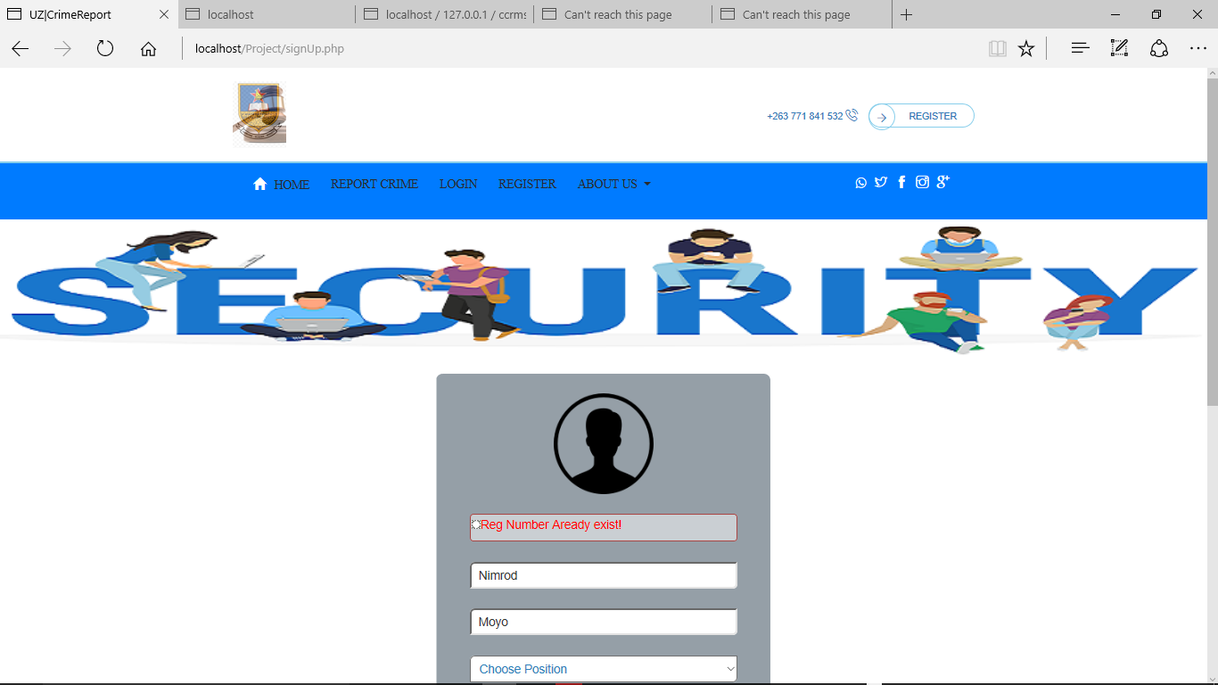

*Screenshot 5.1 – displaying input errors*

All errors are displayed here.

All details are checked and validated before being submitted to the database

Reg number already exists in the database error occurs when one tries to register with a reg number already registered. This is because the reg number is a primary key for user records

**The picture below shows criminal profile displayed by the system.**

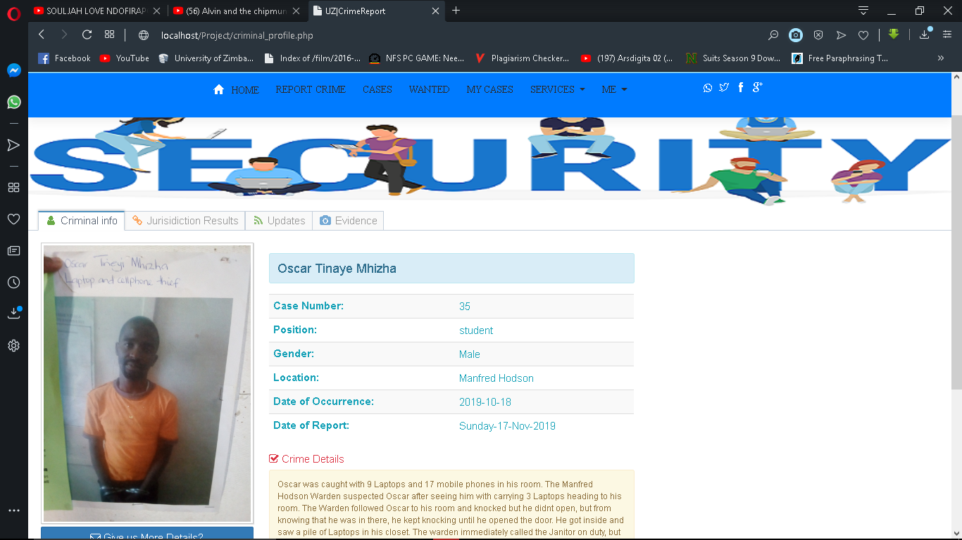

*Screenshot 5.2 – Criminal Profile, with all relevant information*

Criminal’s picture is also displayed if any

Retrieval of all the demographic data about a criminal after clicking more button

**Data retrieval testing**

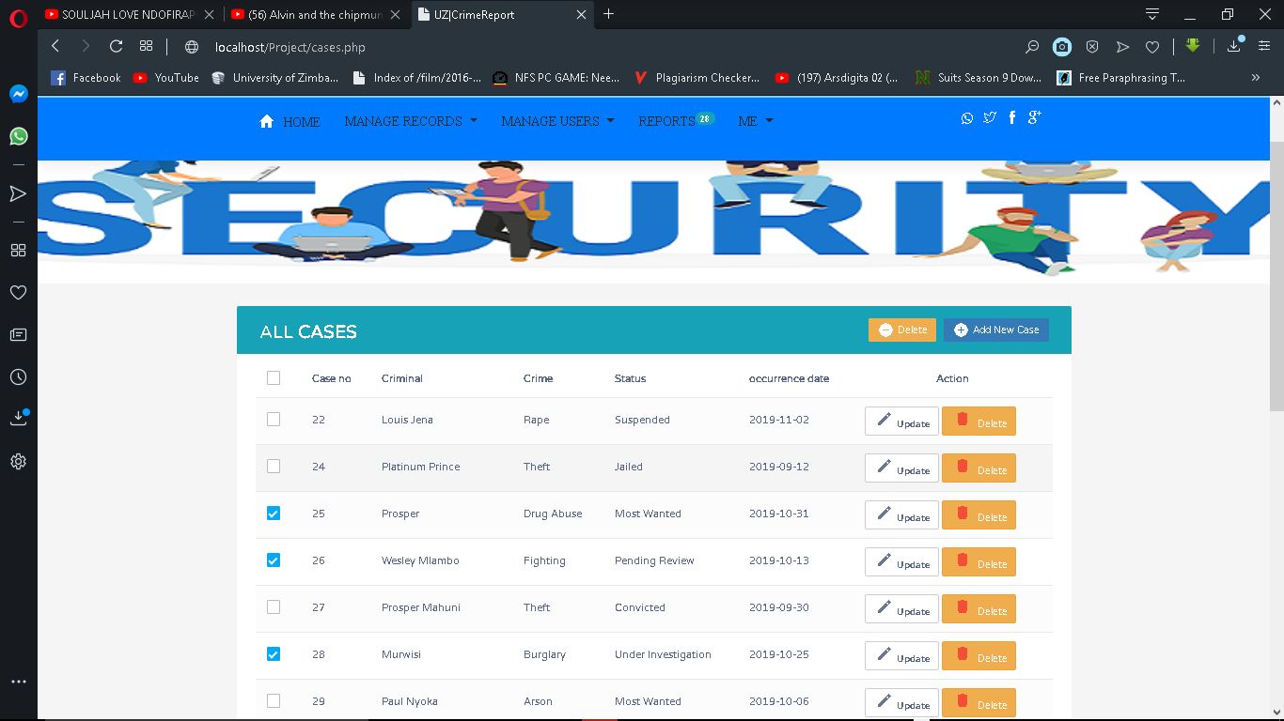

*Screenshot 5.3 – Cases Data Retrieval For Public Domain Release*

Data retrieved from different normalised tables and have Admin privilege view

*Screenshot 5.5 Admin creating user*

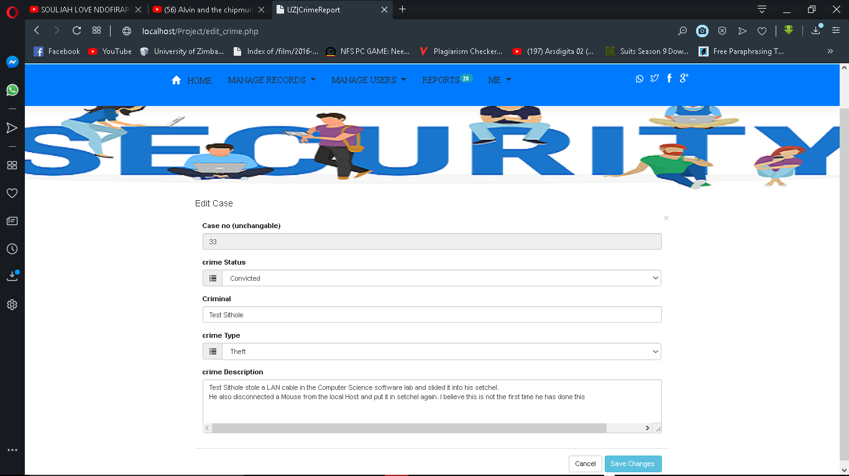

Admin updating the details of crime records

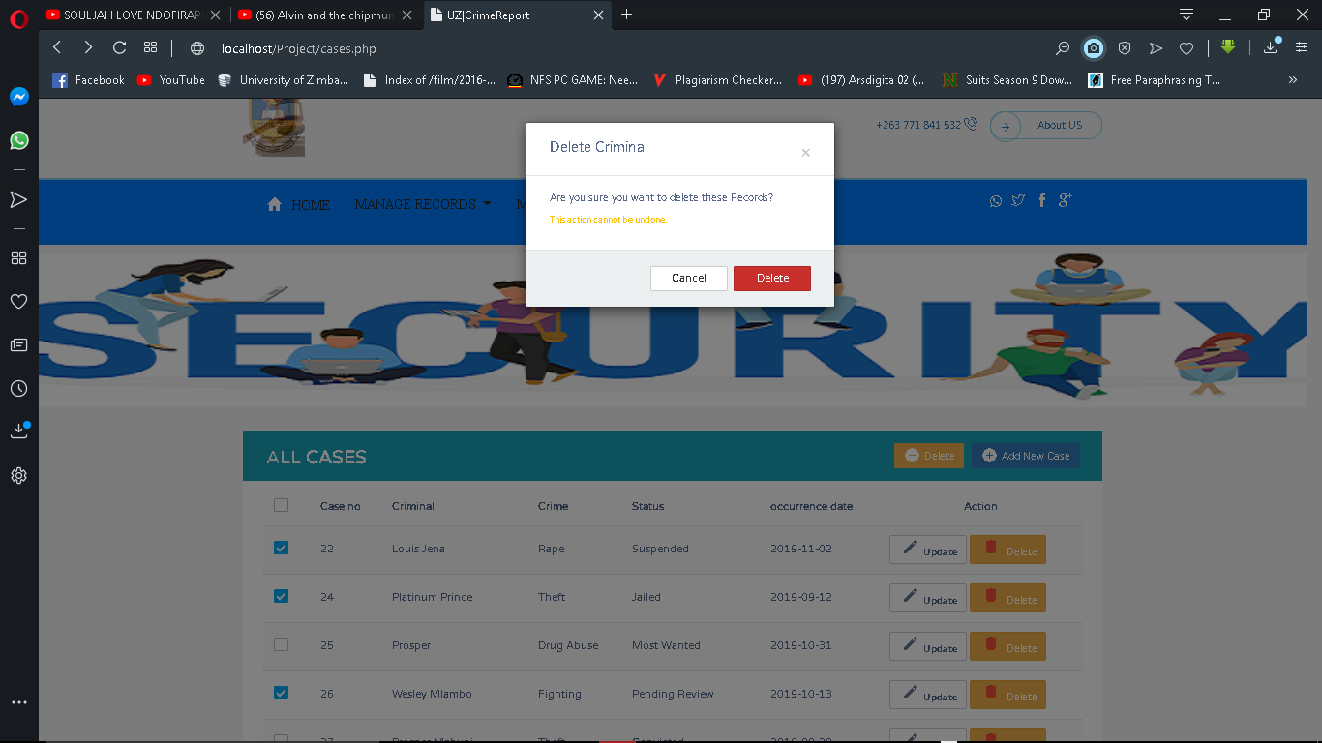

*Screenshot 5.5 – Prompting user before deleting information from users*

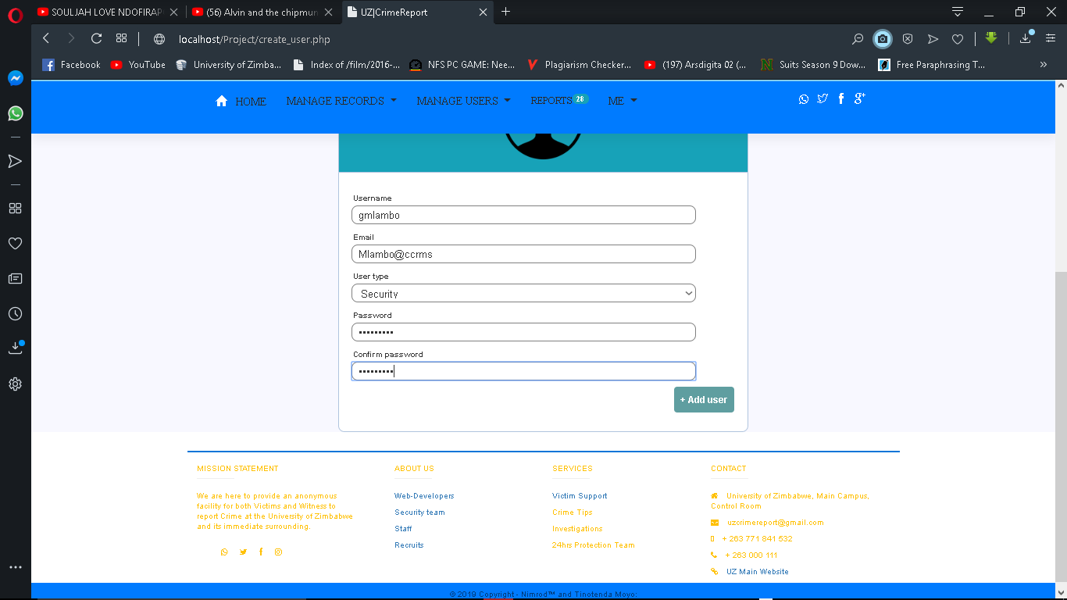

Screenshot 5.6 -Creating user by Admin

**5.6.1 System Testing**

The integrated CCRMS was then tested with the following methods

**Blackbox Testing**

No reference was made to the code in this type of testing. The system is taken as Blackbox, that requires inputs and produce outputs without much knowledge of what goes inside. The whole integrated system was tested by inputting all relevant data to test correctness of data input, to test also the correctness of output as well as the correctness of data and systems validation rules. Output results were compared with the expected results.

**White Box Testing**

In this type of testing, reference was made to the code. Step by step running of system was conducted with report and output at each step of the execution, verification and validation was done at each significant code segment

**Stress Testing**

In stress testing, the system was exercised beyond its maximum design load. Stressing the system often causes defects to come to light. Many members connected to the system at once and the system showed sign of robustness

**Test Results**

The expected results were produced and necessary debugging was done on the modules whose results were variance with the expected set of data.

The system can sustain a limited number of members so as to prevent the slowness in retrieving and saving data to the database if multiple users connect to the system

**Chapter 6**

Conclusion

6.1 Summary

Based on the already mentioned objectives of the CCRMS has made the following achievements:

* Minimized crime on Campus
* Can now facilitate prompt crime reporting on Campus
* Security can now manage crime records though this system
* Minimized time and material consumption through the automation of already existing systems.
* Students can report anonymously by reporting crime without logging in.
* Reduced the workload of having to do the task manually which was somehow exhausting
* Students can now report their crimes in the comfort of their hostels in case the crime happened at night.

6.2 Problems encountered:

In the development process the Campus Crime Reporting and Management System, there were some constraints which were encountered. These problems include:

* Collection of user’s requirements. Users were giving information which was ambiguous
* Inadequate time to allocate for the project which led to compromising on its quality
* Continual change of some requirements by system users.
* Inadequate resources by the university side which led the developers to provide their own resources which were used in this project
* Inadequate time to finish our t our mobile application.
* Lack of knowledge on how to develop android app, the developer had to go through the course of developing android application and then later started the development which took most of our time

Due to lack of adequate time, developers did not manage to finish the project as planned, but we were almost done. We hope to continue with the project until it is finished.

**6.3 Suggestions for Better Approaches to Project Problems**

* Recourses meant for projects should be available so as to not clash with lecture computers in the hardware and software lab
* More time should be allocated for the projects by the University Since it is a process with many steps and needs to be done in a different manner. We suggest giving student two semesters to for the projects since some of the stuff they will be using was not covered in lectures.
* University should provide education facilities in designing mobile applications

**6.4 Suggestions for Future Extension to project**

The system can be extended to form a system which will be used by almost every university in Zimbabwe. We can adjust the current requirements and meet each universities requirement.

Google maps can be imbedded in the system to send the exact coordinates of the crime scene.

**Documentation of code**

The following is the main script for crime reporting. It captures the crime report form html code and the PHP code for sending reported data to the database. In implementing the code, a separate header was used and is simply imported to reduce redundancy.

<?PHP

include("file_upload_handler.PHP"); //Process Files to be stored

$_SESSION['message']='';

include("server.PHP");

// **** INITIALISING VARIABLES

//Crime

 $crime_type = "";

 $crimedescription = "";

 $crimeLocation = "";

 $crimeDate = "";

 $reportDate = "";

 $status = "Pending Review";

 //Criminal

$cName = "";

$cPosition = "";

$cGender = "";

$cdescription = "";

$cPicture = "";

//Reporter's Details

$rName = "";

$rGender = "";

$rEmail = "";

$rPhoneNumber = "";

$witness_1 = "";

$witness_1_no = "";

$witness_2 = "";

$witness_1_no = "";

//Evidence

$vName = "";

$vPhone = "";

$evidence_1 = "";

$evidence_1 = "";

$evidence_2 = "";

$evidence_2 = "";

$evidence_3 = "";

$support_evidence = "";

try{

    if (isset($_POST['send_report'])) {

       // receive all input values from the form

       $crime_type = $_POST['crime_type'];

       $crimedescription = $_POST['crimeDescription'];

       $crimeLocation = $_POST['crimeLocation'];

       $crimeDate = $_POST['crimeDate'];

       $reportDate = $_POST['reportDate'];

       //Criminal's Details

       $cName = $_POST['cName'];

       $cPosition = $_POST['cPosition'];

       $cGender = $_POST['cGender'];

       $cDescription = $_POST['cDescription'];

       $cPicture = $_FILES['cPicture']['tmp_name'];

       //$cPicture = mysql_real_escape_string($cPicture);

       //$cPicture = base64_encode(file_get_contents(addslashes($cPicture)));

       $cPicture = $_FILES['cPicture']['name'];

       $imgContent = addslashes(file_get_contents($cPicture));

       // destination of the file on the server

       //****** */

//        $image = $_FILES['image']['name'];

//      // Get text

//      $image_text = mysqli_real_escape_string($db, $_POST['image_text']);

//      // image file directory

//      $target = "images/".basename($image);

//      $sql = "INSERT INTO images (image, image_text) VALUES ('$image', '$image_text')";

//      // execute query

//      mysqli_query($db, $sql);

//      if (move_uploaded_file($_FILES['image']['tmp_name'], $target)) {

//              $msg = "Image uploaded successfully";

//      }else{

//              $msg = "Failed to upload image";

//      }

//   }

//   $result = mysqli_query($db, "SELECT * FROM images");

       //Reporter's Details

       $rName = $_POST['rName'];

       $rGender = $_POST['rGender'];

       $rPosition = $_POST['rPosition'];

       $rEmail = $_POST['rEmail'];

       $rPhoneNumber = $_POST['rPhoneNumber'];

       $witness_1 = $_POST['witness_1'];

       $witness_1_no = $_POST['witness_1_no'];

       $witness_2 = $_POST['witness_2'];

       $witness_2_no = $_POST['witness_2_no'];

       //Evidence

       $vName = $_POST['vName'];

       $vPhone = $_POST['vPhone'];

       $evidence_1 = file_get_contents($_FILES['evidence_1']['tmp_name']);

       $evidence_1 = mysql_real_escape_string($evidence_1);

       $evidence_2 = file_get_contents($_FILES['evidence_2']['tmp_name']);

       $evidence_2 = mysql_real_escape_string($evidence_2);

       $evidence_3 = file_get_contents($_FILES['evidence_3']['tmp_name']);

       $evidence_3 = mysql_real_escape_string($evidence_3);

       $support_evidence = $_POST['evidenceDescription'];

//*****THE CONCEPT OF NORMALISATION WAS IMPLEMENTED HERE.

Normalisation is the process of taking data from a problem and reducing it to a set of relations while ensuring data integrity and eliminating data redundancy. Data integrity - all of the data in the database are consistent, and satisfy all integrity constraints.

The tables were normalised up to third normal form (3NF)

*****//

       // ******INSERTING INTO CRIME TABLE

           $insert_query = "INSERT INTO crime (type,description,occurrence_Location,occurrence_date,report_date)

                   VALUES('$crime_type','$crimedescription','$crimeLocation','$crimeDate ','$reportDate');";

           $count = $db->exec($insert_query);

           $crime_id = $db->lastInsertId();

        // ******INSERTING INTO REPORTER TABLE

           $insert_query = "INSERT INTO reporter (name,position,gender,email,phone)

                   VALUES('$rName','$rPosition','$rGender','$rEmail','$rPhoneNumber')";

            $count = $db->exec($insert_query);

            $reporter_id = $db->lastInsertId();

        // ******INSERTING INTO CRIMINAL TABLE

           $insert_query = "INSERT INTO criminal (name,position,gender,description,picture)

                   VALUES('$cName','$cPosition','$cGender','$cDescription','$cPicture')";

           $count = $db->exec($insert_query);

           $criminal_id = $db->lastInsertId();

        // ******INSERTING INTO VICTIM TABLE

           $insert_query = "INSERT INTO victim (crime_id,name,phone)

                   VALUES('$crime_id','$vName','$vPhone')";

           $count = $db->exec($insert_query);

         // ******INSERTING INTO EVIDENCE TABLE

           $insert_query = "INSERT INTO evidence (crime_id,evidence_1,evidence_2,evidence_3)

                   VALUES('$crime_id','$evidence_1','$evidence_2','$evidence_3')";

           $count = $db->exec($insert_query);

           // ******INSERTING INTO WITNESS TABLE

           $insert_query = "INSERT INTO witness (crime_id,name,phone)

                   VALUES('$crime_id','$witness_1','$witness_1_no')";

           $count = $db->exec($insert_query);

           $insert_query = "INSERT INTO witness (crime_id,name,phone)

                   VALUES('$crime_id','$witness_2','$witness_2_no')";

           $count = $db->exec($insert_query);

       // ******INSERTING INTO CASE TABLE

           $insert_query = "INSERT INTO `case` (status,criminal_id,crime_id,reporter_id)

                   VALUES('$status','$criminal_id','$crime_id','$reporter_id')";

           $count = $db->exec($insert_query);

           header('Location: home.PHP');

           exit();

       }

           }catch (PDOException $e) {

               echo $e->getMessage();

         }

         //DETECTING ACCESS LEVELS AND SAeNDING THE RIGHT HEADERS

if(isset($_SESSION['username'])){

    include('header_2.html');

}else{

    include('header_1.html');

}

include("reportCrime.html");

include("footer.html");

// while (isset($_SESSION['message'])){

//     //echo $_SESSION['error'];

//     echo "<div class='notloggederror'>";

//     echo $_SESSION['message'];

//     echo "</div>";

//     $_SESSION['message']='';

//     break;

// }

?>

//******HTML CODE FOR CRIME REPORTING Form*****//

<!DOCTYPE html>

<html lang="en" >

<head>

  <link rel="stylesheet" href="https://cdnjs.cloudflare.com/ajax/libs/meyer-reset/2.0/reset.min.css">

  <link rel="stylesheet" href="./css/form_and_stepper.css">

</head>

<body>

<form class="well form-horizontal col-lg-8 col-md-12 col-sm-12 col-xs-12" id="msform"

 action="reportCrime.PHP" method="POST"  autocomplete="on">

  <!-- progressbar -->

<ul autofocus id="progressbar">

  <li class="active">Crime Details</li>

  <li>Criminal Details</li>

  <li>Reporter's info</li>

  <li>Victim details & Upload Evidence</li>

</ul>

  <!-- fieldsets -->

  <!--CRIME DETAILS-->

  <fieldset>

    <h2 class="fs-title text-primary">Crime Details</h2>

    <div class="form-group">

        <label class="col-lg-3 col-md-4 col-sm-4 col-xs-6 control-label">Crime Type:</label>

        <div class="col-lg-8 col-md-12 col-sm-12 col-xs-12 inputGroupContainer">

         <div class="input-group">

            <span class="input-group-addon" style="max-width: 100%;"><i class="glyphicon glyphicon-list"></i></span>

            <select autofocus class="selectpicker form-control" name="crime_type" required>

             <option value="Unspecified">Choose Crime Type</option>

             <option>Laptop Theft</option>

             <option>Drug Abuse</option>

             <option>Rape</option>

             <option>Arson</option>

             <option>Corruption</option>

             <option>Theft</option>

             <option>Fighting</option>

             <option>Other</option>

             </select>

         </div>

        </div>

       </div>

       <div class="form-group">

          <label class="col-lg-3 col-md-4 col-sm-4 col-xs-6 control-label">Crime Description:</label>

          <div class="col-lg-8 col-md-6 col-sm-12 col-xs-12 inputGroupContainer">

           <div class="input-group"><span class="input-group-addon"><i class="glyphicon glyphicon-list"></i></span>

            <textarea auto focus name="crimeDescription" rows= "6" required

             placeholder="Describe the details of the crime" class="form-control"type="text"></textarea></div>

          </div>

         </div>

         <div class="form-group">

            <label class="col-lg-3 col-md-4 col-sm-4 col-xs-6 control-label">Location of Occurance:</label>

            <div class="col-lg-8 col-md-12 col-sm-12 col-xs-12 inputGroupContainer">

             <div class="input-group"><span class="input-group-addon"><i class="glyphicon glyphicon-user">

            </i></span><input autofocus name="crimeLocation" class="form-control" type="text"></div>

            </div>

           </div>

      <div class="form-group">

       <label class="col-lg-3 col-md-4 col-sm-4 col-xs-6 control-label">Date of Occurance:</label>

       <div class="col-lg-8 col-md-12 col-sm-12 col-xs-12 inputGroupContainer">

        <div class="input-group"><span class="input-group-addon"><i class="glyphicon glyphicon-time"></i></span>

          <input autofocus type="date" name="crimeDate" class="form-control"></div>

       </div>

      </div>

      <div class="form-group">

          <label class="col-lg-3 col-md-4 col-sm-4 col-xs-6 control-label">Date of Report:</label>

          <div class="col-lg-8 col-md-12 col-sm-12 col-xs-12 inputGroupContainer">

           <div class="input-group"><span class="input-group-addon"><i class="glyphicon glyphicon-time"></i></span>

            <select class="form-control" autofocus name="reportDate"><option><?PHP echo date("l-d-M-Y"); ?></option></select>

          </div>

          </div>

      </div>

  </fieldset>

<!--CRIMINAL DETAILS-->

  <fieldset>

    <h2 class="fs-title text-primary">Criminal Details</h2>

    <h3 class="fs-subtitle text-info">All known details of the perpetrator</h3>

      <div class="form-group">

       <label class="col-lg-3 col-md-4 col-sm-4 col-xs-6 control-label">Criminal's Name:</label>

       <div class="col-lg-8 col-md-12 col-sm-12 col-xs-12 inputGroupContainer">

        <div class="input-group"><span class="input-group-addon"><i class="glyphicon glyphicon-user"></i></span>

          <input name="cName" placeholder="Full Name" class="form-control" autofocus type="text" required></div>

       </div>

      </div>

      <div class="form-group">

          <label class="col-lg-3 col-md-4 col-sm-4 col-xs-6 control-label">Position:</label>

          <div class="col-lg-8 col-md-12 col-sm-12 col-xs-12 inputGroupContainer">

           <div class="input-group"><span class="input-group-addon"><i class="glyphicon glyphicon-user"></i></span>

             <select class="form-control" name="cPosition">

               <option value="student">Student</option>

               <option value="lecturer">Lecturer</option>

               <option value="dacs personnel">DACs Personnel</option>

               <option value="security personnel">Security Personnel</option>

               <option value="admin personnel">Admin Personnel</option>

               <option value="works personnel">Works Personnel</option>

               <option value="other">Other</option>

             </select>

            </div>

          </div>

      </div>

      <div class="form-group">

          <label class="col-lg-3 col-md-4 col-sm-4 col-xs-6 control-label">Gender:</label>

          <div class="col-lg-8 col-md-12 col-sm-12 col-xs-12 inputGroupContainer">

           <div class="form-horizontal">

             Male: <input type="radio" name="cGender" value="Male" class="">

             Female: <input type="radio" name="cGender" value="Female" class="">

            </div>

          </div>

      </div>

      <div class="form-group">

        <label class="col-lg-3 col-md-4 col-sm-4 col-xs-6 control-label">Additional Description of the Criminal:</label>

        <div class="col-lg-8 col-md-12 col-sm-12 col-xs-12 inputGroupContainer">

          <div>

            <textarea class="form-control" rows="4" name="cDescription" placeholder="Other relevent Description of the Criminal, eg Reg Number,Program,Id Number et ceteris"></textarea>

          </div>

          </div>

        </div>

      <div class="form-group">

       <label class="col-lg-3 col-md-4 col-sm-4 col-xs-6 control-label">Upload Picture:</label>

       <div class="col-lg-8 col-md-12 col-sm-12 col-xs-12 inputGroupContainer">

        <div class="input-group"><span class="input-group-addon"><i class="glyphicon glyphicon-file"></i></span>

          <input name="cPicture" class="form-control" value="Upload picture if any" type="file">

        </div>

       </div>

       </div>

  </fieldset>

  <!--REPORTER DETAILS-->

  <fieldset>

    <h2 class="fs-title text-primary">Reporter's Details:</h2>

    <h3 class="fs-subtitle text-info jumbotron text-center">

      This step optional you may skip it

      <div>

      <article id="titleJumbotron">You may submit this report anonymously if you do not wish to provide a name or other identifying information

        at this time. However, the nature of anonymous reports makes responsive actions more difficult and at times,

         impossible.</article>

        </div>

     </div>

    </h3>

    <div>

      <div class="form-group">

       <label class="col-lg-3 col-md-4 col-sm-4 col-xs-6 control-label">First Name:</label>

       <div class="col-lg-8 col-md-12 col-sm-12 col-xs-12 inputGroupContainer">

        <div class="input-group"><span class="input-group-addon"><i class="glyphicon glyphicon-user"></i></span>

          <input name="rName" autofocus placeholder="Your Full Name" class="form-control" autofocus type="text"></div>

       </div>

      </div>

         </div>

         <div class="form-group">

            <label class="col-lg-3 col-md-4 col-sm-4 col-xs-6 control-label">Position:</label>

            <div class="col-lg-8 col-md-12 col-sm-12 col-xs-12 inputGroupContainer">

             <div class="input-group"><span class="input-group-addon"><i class="glyphicon glyphicon-user"></i></span>

               <select class="form-control" name="rPosition">

                 <option>Student</option>

                 <option>Lecturer</option>

                 <option>DACs Personnel</option>

                 <option>Security Personnel</option>

                 <option>Admin Personnel</option>

                 <option>Works Personnel</option>

                 <option>Other</option>

               </select>

              </div>

            </div>

        </div>

        <div class="form-group">

            <label class="col-lg-3 col-md-4 col-sm-4 col-xs-6 control-label">Gender:</label>

            <div class="col-lg-8 col-md-12 col-sm-12 col-xs-12 inputGroupContainer">

             <div class="">

               Male: <input type="radio" name="rGender" value="Male" autofocus class="">

               Female: <input type="radio" name="rGender" value="Female" class="">

              </div>

            </div>

        </div>

      </div>

      <div class="form-group">

       <label class="col-lg-3 col-md-4 col-sm-4 col-xs-6 control-label">Email:</label>

       <div class="col-lg-8 col-md-12 col-sm-12 col-xs-12 inputGroupContainer">

        <div class="input-group"><span class="input-group-addon"><i class="glyphicon glyphicon-envelope"></i></span>

          <input id="state" name="rEmail" placeholder="example@gmail.com" class="form-control"  type="email"></div>

       </div>

      </div>

      <div class="form-group">

       <label class="col-lg-3 col-md-4 col-sm-4 col-xs-6 control-label">Phone Number:</label>

       <div class="col-lg-8 col-md-12 col-sm-12 col-xs-12 inputGroupContainer">

        <div class="input-group"><span class="input-group-addon"><i class="glyphicon glyphicon-earphone"></i></span>

          <input id="rPhone" name="rPhoneNumber" placeholder="Your Phone Number" class="form-control" type="number">

        </div>

       </div>

      </div>

      <article>

        <h3>Witnesses</h3>

        <div class="form-group">

            <label class="col-lg-3 col-md-4 col-sm-4 col-xs-6 control-label">1st Witness:</label>

            <div class="col-lg-8 col-md-12 col-sm-12 col-xs-12 inputGroupContainer">

             <div class="input-group"><span class="input-group-addon"><i class="glyphicon glyphicon-user"></i></span>

               <input name="witness_1" placeholder="Enter Witness Full Name" class="form-control" type="text"></div>

            </div>

          </div>

          <div class="form-group">

              <label class="col-lg-3 col-md-4 col-sm-4 col-xs-6 control-label">Phone Number:</label>

              <div class="col-lg-8 col-md-12 col-sm-12 col-xs-12 inputGroupContainer">

               <div class="input-group"><span class="input-group-addon"><i class="glyphicon glyphicon-earphone"></i></span>

                 <input id="rPhone" name="witness_1_no" placeholder="Phone Number" class="form-control" type="number">

               </div>

              </div>

             </div>

          <div class="form-group">

            <label class="col-lg-3 col-md-4 col-sm-4 col-xs-6 control-label">2nd Witness:</label>

            <div class="col-lg-8 col-md-12 col-sm-12 col-xs-12 inputGroupContainer">

             <div class="input-group"><span class="input-group-addon"><i class="glyphicon glyphicon-user"></i></span>

               <input name="witness_2" placeholder="Enter Witness Full Name" class="form-control" type="text"></div>

            </div>

          </div>

          <div class="form-group">

              <label class="col-lg-3 col-md-4 col-sm-4 col-xs-6 control-label">Phone Number:</label>

              <div class="col-lg-8 col-md-12 col-sm-12 col-xs-12 inputGroupContainer">

               <div class="input-group"><span class="input-group-addon"><i class="glyphicon glyphicon-earphone"></i></span>

                 <input id="rPhone" name="witness_2_no" placeholder="Phone Number" class="form-control" type="number">

               </div>

              </div>

             </div>

      </article>

  </fieldset>

  <!--UPLOAD EVIDENCE-->

  <fieldset>

    <h2 class="fs-title text-primary">VICTIM DETAILS & UPLOAD EVIDENCE</h2>

    <h3 class="fs-subtitle text-info">victim and supporting evidence:</h3>

    <div class="form-group">

      <label class="col-lg-3 col-md-4 col-sm-4 col-xs-6 control-label">Victim Full Name:</label>

      <div class="col-lg-8 col-md-12 col-sm-12 col-xs-12 inputGroupContainer">

       <div class="input-group"><span class="input-group-addon"><i class="glyphicon glyphicon-user"></i></span>

         <input name="vName" autofocus placeholder="Enter Victim Full Name" class="form-control" type="text"></div>

      </div>

    </div>

    <div class="form-group">

        <label class="col-lg-3 col-md-4 col-sm-4 col-xs-6 control-label">Phone Number:</label>

        <div class="col-lg-8 col-md-12 col-sm-12 col-xs-12 inputGroupContainer">

         <div class="input-group"><span class="input-group-addon"><i class="glyphicon glyphicon-earphone"></i></span>

           <input id="rPhone" autofocus name="vPhone" placeholder="Phone Number" class="form-control" type="number">

         </div>

        </div>

       </div>

    <div>

    <input type="file" autofocus name="evidence_1" value="evidence_1" autofocus/>

    </div>

    <div>

    <input type="file" name="evidence_2" autofocus/>

    </div>

    <div>

    <input type="file" name="evidence_3" autofocus />

    </div>

    <div>

    <textarea class="form-control" name="evidenceDescription" rows="7" placeholder="Supporting information that has not been provided"></textarea>

    </div>

    <button type="submit" name="send_report" class="btn btn-lg btn-warning ">send report</button>

  </fieldset>

</form>

<!-- partial -->

<script src='https://cdnjs.cloudflare.com/ajax/libs/jquery/2.1.3/jquery.min.js'></script>

<script src='https://cdnjs.cloudflare.com/ajax/libs/jquery-easing/1.3/jquery.easing.min.js'></script>

</body>

</html>